COM00147M

Department of Computer Science

Computer and Mobile Networks

Summative Assessment Brief

Total Words: 3, 000

# Task 1 - Network Design

# Task 2 - IT Director Concerns

# Task 3 - CISO Concerns

# A black background with a black square Description automatically generated with medium confidenceAppendices

Figure 1: Legend diagram

Figure 2a: IT department Cloud-Based Servers

Figure 2b: IT Department Data Centre

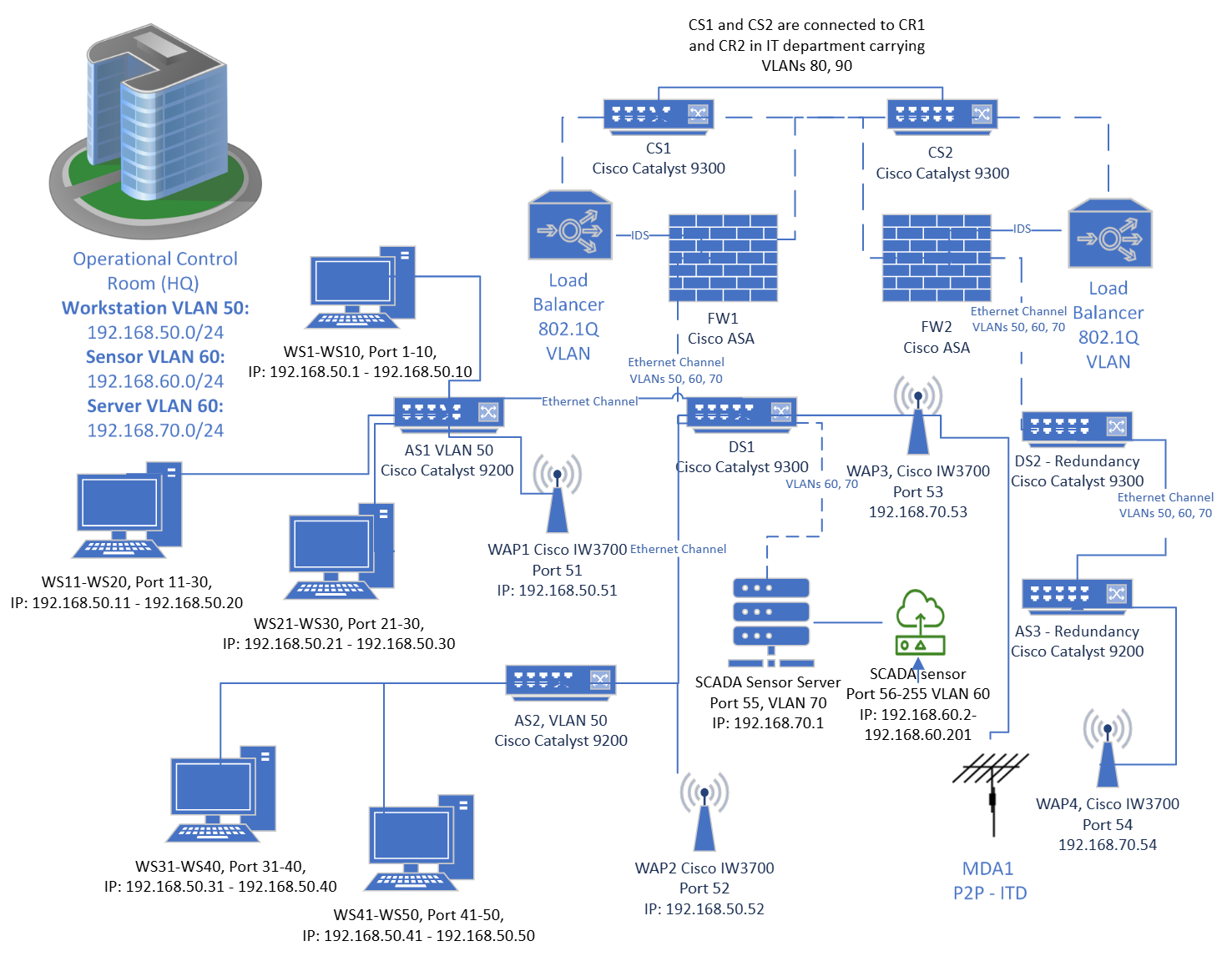

Figure 4: Operational Control Room

Figure 4: Laboratory

Figure 5: Birdseye view of the water treatment plant